How Can I Help Make Refugees Welcome in Sheffield?

Hundreds of thousands of people have been moved to action by the recent refugee crisis and South Yorkshire people are leading the way with offers to help, donate and campaign.
Here are some ways that you can get involved and help
You can:
- Give things or money
- Give your time
- Host a refugee family
- Learn about the reasons behind the crisis and campaign for change
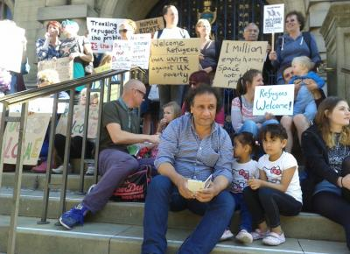
Sheffield says Refugees Welcome 6th Sept 2015 (photo by Manuch)

Give things or money
Various organisations are collecting donations of items needed by refugees in Calais, Greece and around Europe. They will be transported by volunteers.
For a list of what to take, see the Facebook / websites of the groups below. Or have a look at the Calaid website at www.calaid.co.uk/
Main collection point in Sheffield:
Theatre Delicatessen on the Moor,
Thursday to Saturday, 11am - 4pm. S1 4PF - opposite Debenhams.
Please note we can only accept donations during these times. Can we please ask that you do not leave donations outside on the doorstep.
Please check the Calais - People to People Solidarity - Action from Sheffield Facebook page for updates on items needed & ways to volunteer
Trade Unionists supporting refugees Backed by UNITE, the UK’s biggest union. They will be transporting donations directly from Sheffield to the refugee camp in Calais in late October. You can donate money to pay their transport costs. You can invite them to speak at your trade union branch meeting to explain why trade unionists should show solidarity with refugees. Contact via dignitynotdetention@yahoo.co.uk and donate at www.gofundme.com/pitsmoor-calais
Calais – People to People Solidarity – Action from Sheffield Group
Contact: Liam Seward Keep up-to-date with what to donate on Facebook or Website
Sheffield Aid to Refugees
Collecting items for refugees in Kos and Lesvos see their Facebook page
Project Paddington Group set up to mobilise primary school children to send a teddy, a drawing of themselves and a short note to a refugee child. Upon registration, you will receive full information about how to run Project Paddington in your school or group, including our sponsorship page. Initially set up to send teddy bears to children of refugees; also accepting donations in co-operation with TEAR Fund. E-mail: projectpaddingtonuk@gmail.com
Bizzy Bags for Syrian Refugee Children Fundraising campaign - 'Bizzy Bags' which will contain a puzzle book, crayons, jigsaw etc. to send to the various camps in Greece and Calais.
Donations for all of the above organisations can also be left at:
- Sheffield City Council - Town Hall Reception drop off 9am – 5pm Monday to Friday
- Endcliffe Park Café Monday to Friday 9am to 5pm
- One Nation Community Centre, Leyburn Rd entrance S7 1FU – Monday, Wednesday and Friday 6:30PM – 8PM
- Louise Haigh MP office 63 Chesterfield Rd, Sheffield, S8 ORL - Tel 250 8113 Monday to Friday 9am to 5pm
- Harry Harpham MP office at Shirecliffe Community Centre, 349 Shirecliffe Road, S5 8XJ Monday to Friday 9.30 - 4.30

Give your time
You can volunteer with South Yorkshire Refugee Law and Justice who provide support for people seeking asylum who don’t have legal support. They provide their service every Friday from 9.30am at Exchange Brewery, Sheffield S3 8NS. If you have legal training or experience – perhaps you are a law student or retired lawyer - your skills could be particularly useful. They also need help on reception and with admin. You can volunteer for just 2 hours per week and they will train and support you. Contact them at syrljcoordinator@gmail.com for a chat about how you can help.
Volunteer to help (Sheffield based roles)
When refugee support groups need volunteers, they advertise through the Volunteer Centre Website. To see all their roles available in Sheffield at the moment, go to the Volunteer Centre Website and click Start volunteering.
Visit the Volunteer Centre Drop in Monday – Wednesday from 10-4
Come and talk to a volunteer Advisor at our Drop in. They can talk through what is available and how local charities would like people to support them.

National and international volunteering roles:
● Doctors of the World: providing care to vulnerable people, advocating for rights to health
● Music Against Borders: appealing for people to donate musical instruments to Calais
● The Jungle Library: makeshift library set up at the camp at Calais. They need more books
● 'Childhood bags': fundraising to take books, toys and warm clothes to children
● Migrant Offshore Aid Station: dedicated to preventing loss of life at sea
● Sawa for development and aid: working with Syrian refugees in Lebanon

National and international groups to donate to:
Make a financial donation to a non-governmental organisation (NGO) that is doing related humanitarian work overseas. These could include:
● Save the Children: distributing essential items such as nappies, hygiene kits and food
● Red Cross Europe: providing emergency health services at central train stations
● Migrant Offshore Aid Station: they have raised from donations money to equip three rescue ships already and are trying to raise money for another ship by crowd funding they have rescued 11000 people already this year. See MOAS crowdfunding project 'Peoples Armada' at www.moas.eu
● International Rescue Committee: improving living conditions by setting up camps
● Médecins Sans Frontières: humanitarian agency which has three rescue ships in the Mediterranean www.msf.org.uk
● Aylan Kurdi Fund: named in honour of the drowned child and set up within 24 hours of the horrific pictures circulating around the world. All proceeds are going to charity Hand In Hand For Syria
● Asylum Aid: provides free legal advice and representation to refugees and asylum-seekers seeking safety in the UK from persecution. They also campaign for the fair treatment of refugees in the UK

You can host a refugee family
ASSIST Sheffield runs a hosting scheme for destitute asylum seekers from all nations. Do you have free space in your house and are willing to host a refugee who has no home? Contact ASSIST Sheffield via www.assistsheffield.org.uk

Learn about the reasons for the crisis and campaign for change
It’s good that the situation facing refugees in Europe is getting attention. It’s about time! But it is a shame that people had to suffer so much before we took notice. Why are there so many refugees now? And how can we support their attempts to find safety?
How could Europe and European Governments honour their commitments to support refugees? And what is life like for those refugees who are already in this country?
Find out more and ways to show your support and solidarity by working with a local refugee campaign group. There are many: eg Sheffield Committee to Defend Asylum Seekers or the South Yorkshire Migration and Asylum Action Group (SYMAAG). You can contact SYMAAG (who have produced this guide, alongside Sheffield Volunteer Centre) via dignitynotdetention@yahoo.co.uk on Facebook, Twitter or at our website www.symaag.org.uk
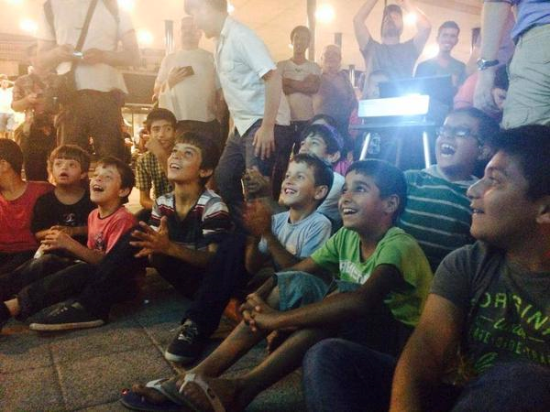
Refugee children enjoy a Tom and Jerry film showing organised by volunteers in Hungary

