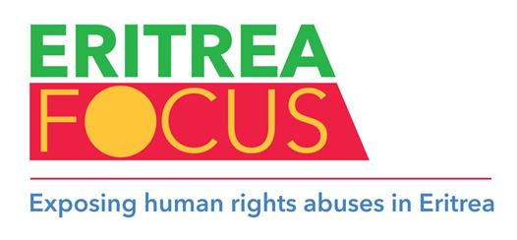

​

​ |  | ​
  Friday 12 June 2015
  Public relations for Nevsun in London next week
  There are meetings taking place in London next week which are of great concern to Eritreans. They involve the visit from Canada of Todd Romaine, Vice President of Corporate Social Responsibility at Nevsun Resources Limited, and Lloyd Lipsett, LKL International, a lawyer who has been engaged in the defence of Nevsun’s nefarious mining interests in Eritrea. They appear to be promoting a public relations ‘charm offensive’ to protect the reputation (such as it is) of the Canadian mining company.
  Their visit coincides with the publication of the UN Commission of Inquiry report on human rights in Eritrea on Monday, 8 June 2015. The report – an appalling catalogue of human rights abuses – contains detailed passages on the Bisha Mine, operated by Nevsun. In brief the report states categorically that forced labour and torture in Eritrea, including at the Bisha mine, may constitute crimes against humanity (see references below). In November last year, three Eritreans filed a lawsuit against Nevsun Resources in Canada, claiming that they worked at the Bisha mine against their will and were subject to ‘cruel, inhuman and degrading treatment’ – the first case of its kind.
  The first meeting, on Monday, 15 June, will be held under the auspices of the Solicitors’ International Human Rights Group (SIHRG) when Romaine and Lipsett will be on a panel to discuss ‘Eritrea: Business Ethics, Migration and Trafficking.’ Last December, SIHRG launched a controversial report, authored by its Vice Chair, Ruby Sandhu. It was a highly coloured and inaccurate description of the true situation in Eritrea, both historically and factually. A robust, point by point, response, through Habte Hagos of Eritrea Focus has been made to SIHRG to which no detailed reply has as yet been received.
  There will then be a meeting at the prestigious Chatham House on 17 June, when the two Nevsun operatives will be discussing ‘Business and Human Rights in Eritrea: Lessons from the Mining Sector.’ Eritrea Focus has written to Chatham House indicating its concern that this important international institute has become part of a public relations exercise in defence of the indefensible.
  Finally, the House of Lords has become part of the Nevsun campaign with the respected parliamentarian, Baroness Oona King, surprisingly hosting an event on 18 June with Romaine and Lipsett prominent as speakers. Once again, Ruby Sandhu seems to be associated with this exercise for Nevsun, raising questions about her relationship with the mining company. She seems to be promoting ‘constructive engagement’ with Eritrea – a message that is not appreciated by the tens of thousands of Eritreans fleeing the country or enduring life in one of the cruellest dictatorships in the world.
  Nevsun’s need for a successful public relations campaign is understandable against a dramatically falling share price and diminishing reputation in the face of their activities in Eritrea. Money speaks and the PR expenses will be a drop in the ocean compared with the rewards for doing business with the pariah regime. Nevsun has generated approximately US $1.6 billion in revenue since 2011 – with $250 million going to the Eritrean Government’s state-owned National Mining Corporation. Rich pickings indeed.
  -ends-
  Sources:
  1. Full report of UN Commission of Inquiry on human rights in Eritrea: http://www.ohchr.org/EN/HRBodies/HRC/CoIEritrea/Pages/ReportCoIEritrea.aspx
  2. See paragraphs 1085, 1409, and 1435 of the UN’s full report which refer to the human rights abuses that have taken place in the Bisha Mine.

​ | ​ | ​

​ |  | ​

​ | ​ | ​

​ |  | ​

​

Eritrea Focus is an association of Non-Governmental Organisations (NGOs), human rights organisations, exile and refugee groups and individuals concerned with the gross abuse of human rights in Eritrea.

