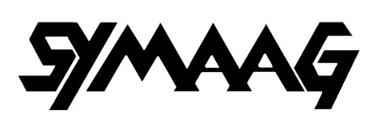

South Yorkshire Migration and Asylum Action Group
c/o 45 Oak Hill Road
Sheffield S7 1SJ
0114 296 0806
davidprice2@googlemail.com
5 September 2014
The Rt Hon Nick Clegg MP
85 Nether Green Road
Sheffield, S11 7EH

Syria, War and Refugees

On 14 August, SYMAAG held a meeting on this subject. We heard from the Refugee Council about their concern that the UK should take a fair share of the huge number of Syrian refugees and from a Syrian representative about the terrible conditions in his country. At the end of the meeting, the attached resolution was passed unanimously.

This is the worst refugee crisis we can remember. We appreciate your commitment to the UK taking Syrian refugees. We would hope that you could use your influence to ensure that the numbers taken are ‘several thousands’ as in our resolution rather than the pitiful number now envisaged.

We are also approaching Sheffield City Council and other Councils in South Yorkshire to urge them to play their part in taking Syrian refugees.

Finally, we are urging the Home Office to process quickly and efficiently asylum claims from Syria asylum seekers already in this country.

Yours sincerely,

David Price

