Sheffield City Council:
Don't do business with
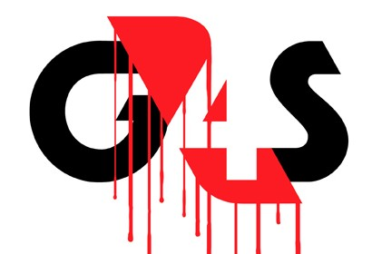
Lobby Sheffield City Council
1pm Wed 2nd July, Sheffield Town Hall
We ask you to exclude G4S from the tendering process of Sheffield City Council and not to under any circumstances award contracts to G4S, because of the company’s grave misconduct:
1. Unlawful killing: The inquest into the death of Jimmy Mubenga, Angolan refugee, returned a verdict of unlawful killing as a result of restraint by G4S guards on board a deportation flight from the UK. Now four years later, the G4S Security Guards face prosecution for manslaughter
2. Breaking international law: G4S directly supports Israel’s occupation of Palestinian lands. It supplies security services to prisons and detention centres within Israel which hold Palestinian prisoners, including children, illegally transferred from the Occupied Territories in violation of the 4th Geneva Convention. There is compelling evidence of torture in some facilities supplied by G4S and that children are subject to continuing abuse.
3. Profiteering, incompetence and abuse: G4S-provided housing for people seeking asylum is “unacceptably poor” according to the Public Accounts Committee. G4S were given up to £600 million of public money. The result? Cockroach-infested rooms, overcrowding, forced moves to areas with high rates of racist attacks and multiple missed deadlines leaving councils to pick up the pieces.

4.Serious fraud and non-payment of tax: G4S paid no corporation tax in the UK last year. G4S has been under scrutiny by the Serious Fraud Office and was fined £109million for the electronic tagging fraud. Despite this, G4S continues to be awarded public service contracts even where they lack any experience. .

5. Profiting from forced labour: G4S has been a prime contractor in the discredited Work Programme which has resulted in 5 times as many benefit sanctions (stoppages) than successful job outcomes. In May 2014 it was given £60 million of public money to run the punitive "Help to Work" workfare scheme where unemployed people are forced to work for no wages for 6 months.

Sheffield City Council can and should stop any more public money going to G4S

Public contracting bodies have a legal right and a responsibility to exclude a company with such a history from its procurement process. Under the Public Contracts Regulations 2006, a public body may reject a bid where the organisation has ‘committed grave misconduct in the course of their business or profession’. We call on the council to use its discretion under the Public Contracts Regulations 2006 to exclude G4S from bidding on grounds of grave misconduct.

South Yorkshire Stop G4S Campaign c/o South Yorkshire Migration and Asylum Action Group,
Exchange Brewery, 2 Bridge Street, Sheffield S3 8NS. email: dignitynotdetention@yahoo.co.uk

