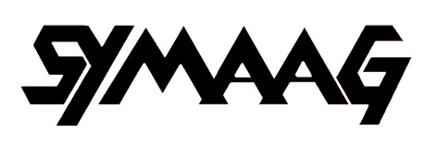

SOUTH YORKSHIRE MIGRATION AND ASYLUM ACTION GROUP

ANNUAL REPORT 2013/14

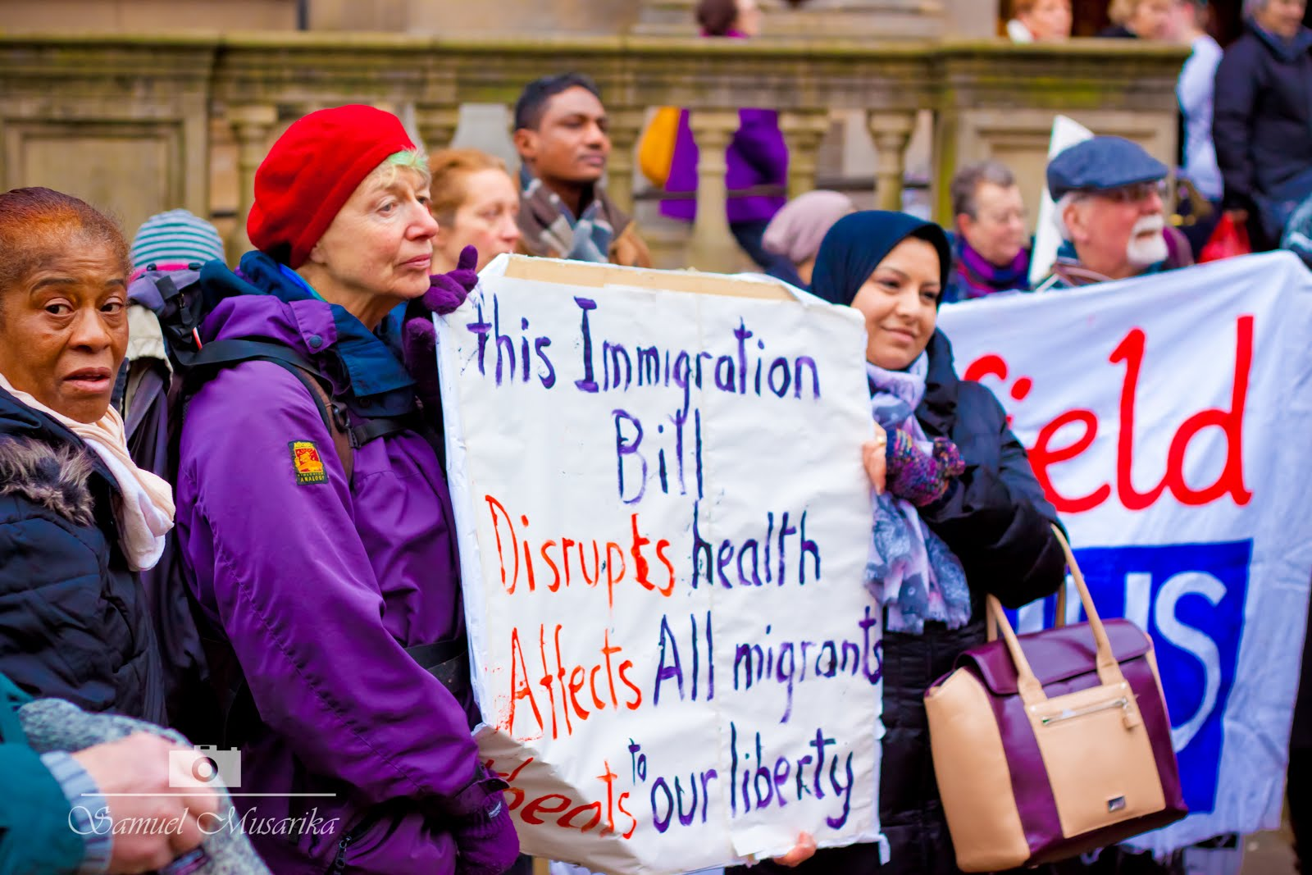

Introduction

- On 11 June 2007 a public meeting was held in Sheffield at which it was agreed to set up the South Yorkshire Migration and Asylum Action Group (SYMAAG) with the following terms of reference:
‘To campaign for action by Government and others to improve the position of asylum seekers (particularly those who have been refused) and exploited migrant workers (including the victims of trafficking).’

- From then on, SYMAAG held monthly meetings at Scotia Works, which were well attended by asylum seekers and refugees as well as other activists from all over South Yorkshire. SYMAAG soon began to organise major events, such as a March to Lindholme Detention Centre and public meetings on the plight of Darfuri asylum seekers and asylum and health. On 21 April 2008, SYMAAG held its inaugural Annual General Meeting at which a Constitution was agreed and the Group became formally constituted, with an elected Executive. Since then, SYMAAG has continued to be a very active campaigning organisation

- This is SYMAAG’s sixth Annual Report and relates to the year ending April 2014. This is the fourth year during which the Coalition Government has been in office. This year has seen an intensification in the Coalition’s anti-migrant rhetoric and policies, with the deplorable Immigration Bill being pushed through Parliament. Meanwhile, the treatment of asylum seekers has for the most part continued to lack either efficiency or compassion. We fear that the Home Office’s recent decision on advisory services will make matters worse (para 15).

SYMAAG meetings and information

4. We have continued to hold open meetings roughly every month or two alternating with Executive Committee meetings, mostly at 2 Bridge Street, Sheffield. Among the subjects discussed have been the Zimbabwean election, cuts to legal aid, the problems of renewal of 5 year refugee status and the crisis in South Sudan. We held two major public meetings – one on 29 October 2013 on Government plans to reduce migrant access to the NHS and the second on 18 February 2014 on politics, racism and the media. On 15 November, we, along with colleagues from sister organisations, met Nick Clegg to protest about the Immigration Bill. On 18 December 2013- the UN’s International Migrants’ Day - we held a demonstration and march against the Immigration Bill. We have also provided speakers for other campaigning groups. These events are described in more depth in this report.

Meetings and information flow summary 2008-14

 | 2013-14 | 2012-13 | 2011-12 | 2010-11 | 2009-10 | 2008-09
“SYMAAG News” bulletins | 8 | 11 | 12 | 13 | 22 | 31
SYMAAG email contact list | 570 | 541 | 546 | 483 | 460 | 300
emails received | Approx 2000 | 2000+ | 1390 | Approx 1000 | Approx 700 | Approx 300
Average attendance at SYMAAG full meetings | 11 | 12 | 13 | 14 | 16 | 20
SYMAAG website hits (individual users) | 5856 | 6130 | 850 | n/a | n/a | n/a
SYMAAG Twitter followers | 231 | 102 | n/a | n/a | n/a | n/a

5. We have continued to operate as a national organisation as well as a local and regional one which is reflected in the numbers of people seeing our work via the SYMAAG website or through social media, particularly Twitter. “SYMAAG News” email bulletins have been useful but to promote particular events rather than more in-depth “news” articles which are better covered on the website and through links to analysis and comments by our members. More members contributed articles for the website this year, though it was updated a little less often than in 2012-13.We hope to develop our use of Facebook as a campaigning tool in the coming year.

The Immigration Bill

6. Our biggest campaigning issue in the last year has been the Immigration Bill, which was designed, according to Theresa May, to create a ‘hostile environment for illegal migrants’. In reality, the hostile environment will affect everybody in this country. Among its provisions are:
- Removal of many important rights of appeal from migrants;
- Intrusive checks on everyone engaged in perfectly normal activities like renting accommodation, taking out a bank account or seeking a driving licence in order to spot ‘illegal migrants’;
- Imposing unnecessary charges on migrants entering the country for their prospective use of the NHS;
- Requiring GPs and Accident and Emergency Departments in hospitals to check whether their patients are illegal migrants.

7. The bill was published on 10 October 2013 and its Second Reading was held less than two weeks later. On 15 November, we challenged Nick Clegg about the implications of the bill for civil liberties and community cohesion and expressed surprise that the Liberal Democrats supported it. For his part, Clegg referred to his negotiations with the Conservatives and indicated that, without his active intervention, it would have been worse. We wrote to Paul Blomfield MP about the bill. He denounced the Bill most effectively at second reading. But disappointingly Labour officially abstained in the vote. Altogether, only 18 MPs voted against – reflecting the abject anti-migrant climate at present in politics and the media.

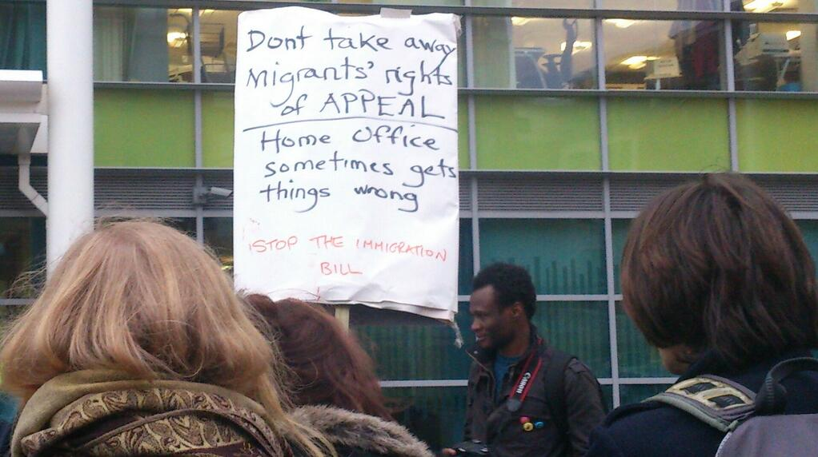
December 18th: Demonstrating against the Immigration Bill outside South Yorkshire
Home Office HQ using the weapon of understatement

8. We have persisted in our opposition to this bill and indeed have probably been the most vigorous campaigning body against it outside London:

- More than 60 people attended our public meeting on 29 October 2013 to discuss the NHS aspects of the bill and the threats to migrant access to the NHS. Speakers included local medical experts. At the end, a resolution was passed unanimously calling on the Government to withdraw these damaging policies and this was passed to all Sheffield MPs.
- We sent a submission critical of the Bill to the House of Commons Bill Committee.
- On 18 December – International Migrants Day – we held a demonstration and march against the bill in Sheffield. Among others, Natalie Bennett, national Leader of the Green Party, spoke eloquently against the bill. This event was attended at the peak by some 120 people and 300 leaflets were handed out. We believe it was the biggest single protest held against the bill in the whole country.
- We wrote to various Peers and Bishops urging them to oppose the bill in the House of Lords.
- On Sunday 5 January, our Chair was interviewed about the bill on 13 local BBC radio stations.
- With 38 Degrees, we helped to launch an online petition against it; however, 38 Degrees did not send it to its huge circulation (apparently on the grounds that it was unlikely to succeed), so it only got around 3,000 signatures.
- On 15 January, our Chair spoke at a packed meeting in the House of Lords about the bill. This meeting was organised by the new Movement against Xenophobia which we have joined. We are represented on its steering committee.

9. Despite valiant efforts by some Peers and Bishops, it is likely that the Bill will become law in broadly its original highly unsatisfactory form - described by a Bishop as ‘pernicious’. Public reaction to this bill has been strangely muted and our campaigns were not matched elsewhere. There is need for reflection among campaigners about how to prevent a similar sequence of events in future.

Asylum housing: the G4S campaign

10. We have continued our high profile campaign against the Home Office’s Compass contract with G4S for the provision of asylum housing throughout Yorkshire and the North East. We are grateful to our Vice Chair, John Grayson, for the energy and leadership he has put into this campaign.

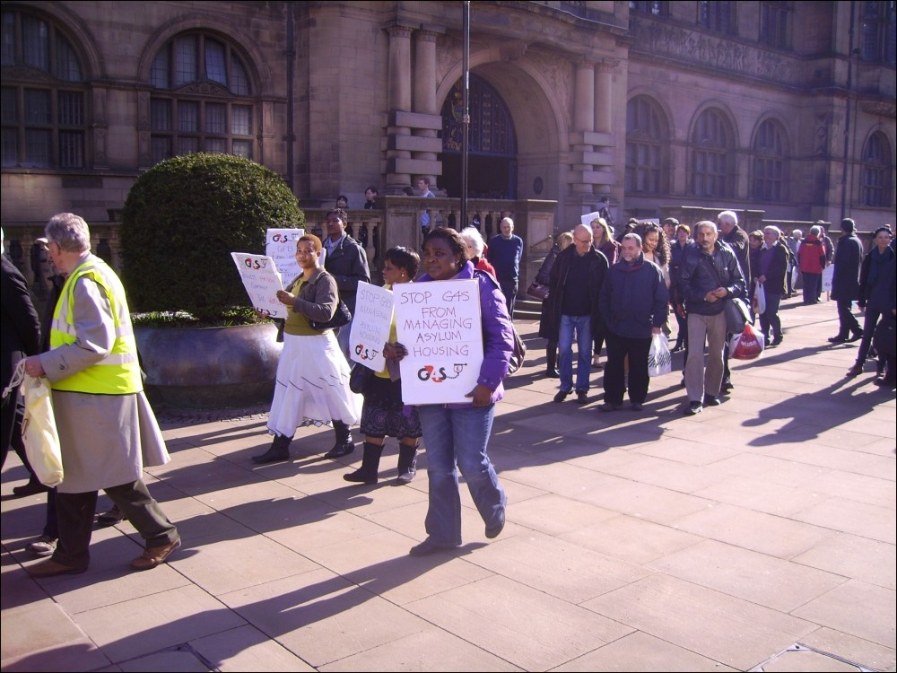
Demonstrating against G4S outside Sheffield Town Hall

11. During the year, the Compass contracts have been ‘breaking up’, with various sub-contractors removed from the contract. Absurd problems have occurred like G4S sub-contractors failing to pay Council Tax or energy bills on their properties. In Yorkshire and the North East, G4S has taken direct control of the work, presumably looking to cut staff.

12. SYMAAG submitted evidence about G4S asylum housing to the Childrens’ Society parliamentary inquiry into support for children in the asylum system; the National Audit Office; the Chief Inspector of Borders and Immigration and the Home Affairs Committee of the House of Commons. The Home Affairs committee held hearings in June 2013 and issued a report in October. The Public Accounts Committee issued a report on the COMPASS contracts and held hearings early in 2014. Various highly critical reports were produced, some of which drew on our evidence, but the Home Office’s contract with G4S remains in place. We are demanding that the Home Office cancels the present COMPASS contract and returns asylum housing to local councils, housing associations and not for profit voluntary housing agencies

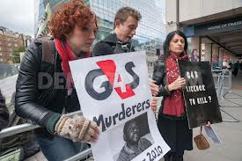
Outside G4S Annual General Meeting 2013

13. We have kept close to the wider issues concerning G4S. In July 2013, an Inquest Jury delivered a verdict of unlawful killing in the case of Jimmy Mubenga who was being escorted by G4S guards on a deportation flight in 2010. His G4S guards are currently facing manslaughter trials. We have supported the national Stop G4S campaign and organised with them a Convergence in Sheffield in February 2014. SYMAAG members are currently researching potential G4S contracts in South Yorkshire and have prepared a petition to convince the Sheffield City Council not to give contracts to the company given its appalling human rights record in what they describe as their detention and housing “asylum markets”; and their appalling international record of servicing prisons where Palestinian children are assaulted and tortured., and mismanaging prisons in South Africa and immigration detention centres for the Australian government.

Other campaigning issues

14 Asylum advice. With the troublesome experience of the G4S contract in mind, we were surprised by the Home Office’s decision to transfer their national contract for providing advice and support to adult asylum seekers as from April 2014 to Migrant Help, a charity based in Dover. Migrant Help was competing against a consortium bid by Refugee Council, Refugee Action, Northern Refugee Centre, North of England Refugee Centre and the Welsh Refugee Council – all of them bodies with vast experience in this field. Our suspicion is that the new providers will rely heavily on telephone contact, will expect customers themselves to use the Home Office website and will cut down fairly drastically on face to face contact. This is a disturbing prospect, given the remarkable complexity of the system, the bewilderment which many asylum seekers feel in trying to navigate it and the decline in available legal help to asylum seekers. We have decided to monitor asylum seekers’ experience with Migrant Help (known under this contract as ‘Asylum Help’).

15. Detention. The UK is apparently the only EU country which detains migrants indefinitely. We have long been disturbed about this infringement of human rights and the damaging effect on migrants’ mental health and wellbeing. Indeed, our first venture was a march to a detention centre. We have now joined the Detention Forum which campaigns on these issues nationally and members of our Executive have attended the Forum’s meetings in London. We have supported and publicised detainees’ protests and hunger strikes from detention centres.

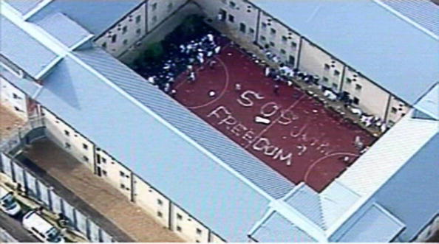
In May 2014 detainees started a mass protest against detention at four
Centres around the country. They need our support

16. Politicians, racism and the media. In the last year, xenophobia has noticeably increased among politicians and the media. The rise of UKIP is partly responsible but we suspect that more fundamentally this reflects a hunt for scapegoats for the prolonged period of ‘austerity’ which has followed the banking crisis of 2008. One example was the media frenzy towards the end of 2013 about a supposed invasion of Bulgarians and Romanians when restrictions on their movement were removed on 1 January 2014. Ministers exacerbated these fears by responding with tighter social security rules. In fact, only a trickle of people arrived from these countries early in 2014. On 18 February we held a meeting on ‘Politicians, racism and the media’ at which the speakers were Emma Briant of Sheffield University and co-author of ‘Bad News for Refugees’ (an analysis of media distortion of asylum issues), Jon Burnett of the Institute of Race Relations and our own Vice Chair, John Grayson. The meeting highlighted the need in the coming election period to monitor carefully media treatment of migration issues and to challenge emotive or racist statements. More recently, we had a local example in what we saw as an over-reaction by David Blunkett MP on BBC Radio Sheffield, to the presence of some Roma families in Page Hall in Sheffield; he later qualified what he had said but only after a media circus had descended on Firvale with anti-Roma stories appearing in many news outlets.

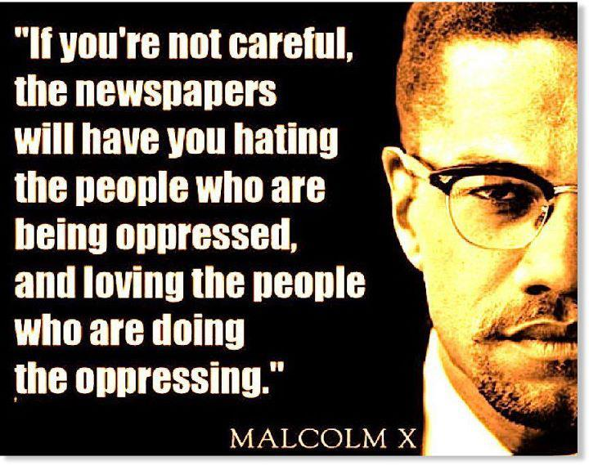
17. Cuts in legal aid and threats to Judicial Review. We have been very concerned at the elimination of legal aid for migrants, with the exception of asylum seekers (though even they will be affected by some of the new rules). With South Yorkshire Refugee Law and Justice and ASSIST, we wrote to the Parliamentary Joint Committee on Human Rights to protest about
- the proposed introduction of a residence test for civil legal aid claimants, so as to limit legal aid to those with a “strong connection” with the UK.
- the proposal that providers of legal services in applications for judicial review against public bodies should only be paid for work done on the case if the Court grants permission for the application to proceed
- the proposal that legal aid should be removed for all cases assessed as having “borderline” prospects of success.
We also expressed our concern about possible restrictions in access to judicial review.

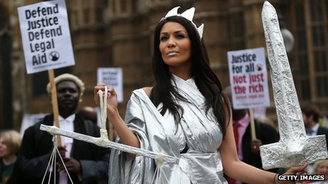

18. Renewal of the right to remain. In and around 2010, a large number of asylum seekers were given 5 years leave to remain. They will soon be seeking renewal of their right to remain. We are concerned about the ability of the Home Office to deal with these renewals with sufficient speed. There is a danger that these people will be thrown back into a limbo of uncertainty in which they might lose their jobs and homes. We took this up with Nick Clegg. The Home Office did not reply to most of our points but they did say that, if a refugee applied in time for renewal, they could continue to work with their current employer until a decision was made on the outstanding case. We have publicised this undertaking. We shall need to monitor what happens to these cases as the Home Office still has backlogs of more than 450,000 unresolved asylum applications.

19. Impact of benefit sanctions on refugees. The Department of Work and Pensions has greatly increased the number and severity of sanctions imposed on unemployed people for alleged failures to seek work with sufficient zeal; this may help to explain the increased use of food banks. We suspect that refugees are particularly vulnerable to such sanctions, perhaps because of imperfect English, perhaps because of prejudice. We have carried out some research and practical advice and support work on this issue and look forward to joint campaigning with community groups, local MPs and trade unions.

Work related to countries

20. Many SYMAAG members come from trouble-torn countries across the world and help the rest of us to understand the issues in those countries. Much of our activity is related to particular countries:

- Zimbabwe is the home country of many of our members. On 16 July 2013 we held a discussion about the Zimbabwean Election with highly informative talks by representatives of the two major opposition parties – MDC-T and MDC. The meeting concluded that through various devices Mugabe’s Zanu PF would win the election and that this would present the opposition parties with a big dilemma as to how far to carry their protests. The meeting was uncannily predictive of what actually occurred – Mugabe’s power has been consolidated.
- South Sudan. On 17 March 2014 Rodrigo Edema, a Ugandan from the extreme north of his country bordering on South Sudan , spoke about his disturbing experiences on a visit to Juba in December to explore issues of mental health. He suddenly found that there was an attempted coup by the Vice President leading to widespread fighting and massacres. Food supplies were running out and travel was dangerous. Uganda intervened and perhaps saved many lives, but the situation was still very unsettled.

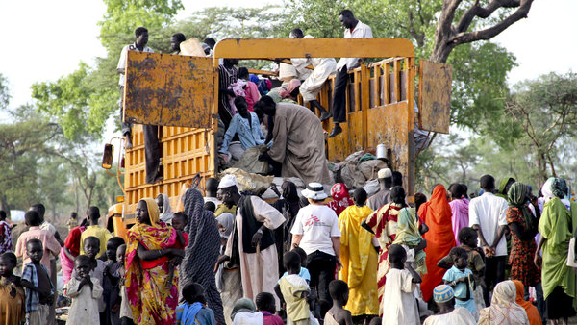
The civil war in South Sudan has created 1000’s of refugees

- Democratic Republic of the Congo. Catherine Ramos from Justice First in Teesside, former speaker at our AGM, has investigated what happened to asylum seekers who were deported to the DRC. Recently, she found that testimony from one of these asylum seekers showed that assurances given to MPs by UKBA in 2012 were incorrect: this man had suffered months of imprisonment and abuse. Paul Blomfield MP has written on our behalf to the Home Office about this, as it raises fundamental issues about the Government’s observance of the 1951 Refugee Convention, which prohibits ‘refoulement’ to dangerous countries.
- Sri Lanka A local Sri Lankan asylum seeker “F” spoke at a SYMAAG meeting to explain the oppression of Muslim and Tamil people by the Sri Lankan government, particularly following end of the civil war. The UK Government continued to attempt to deport people to Sri Lanka, sell arms to the regime and attend a Commonwealth summit there despite these human rights abuses.

Campaigns for individual asylum seekers

21. SYMAAG’s remit is to campaign on general issues affecting migrants, including asylum seekers, while Sheffield CDAS (Committee to Defend Asylum Seekers) campaigns for individual people. There is some cross membership and of course SYMAAG members readily support campaigns for individuals about whom they are concerned. Moreover, our Executive is especially concerned about the position of two of our own member, Marian Machekanyanga from Zimbabwe and Muhammad Bary from Bangladesh who have been struggling to gain refugee status for a long time.

Women asylum seekers

22. We recognise that women refugees can face particular issues specific to their gender: for example, the use of rape as weapon of war and female genital mutilation. SYMAAG is happy to have more female Executive Committee members who are also active within women’s groups such as Development and Empowerment through Women’s Advancement (DEWA) and Why Refugee Women. We continue to work in partnership on campaigns and events affecting women and aim to increase this work in the coming year.

23. We have worked with many women as asylum tenants in G4S asylum housing, supporting their complaints and protests through advocacy, campaign work and publicity. Women members of SYMAAG are currently involved with projects to collect clothing for Syrian refugees in Algeria and advocating for women refugees with health services, local authorities and the Department of Work and Pensions.

Work with other organisations

24. South Yorkshire is fortunate in the number and quality of organisations offering support to asylum seekers and interested in issues affecting migrants. We work closely with these other organisations, notably ASSIST, City of Sanctuary, CDAS South Yorkshire Refugee Law and Justice and Northern Refugee Centre. We are particularly grateful to NRC for use of 2 Bridge Street for many of our meeting and for the helpful advice we receive from its staff. We have also worked with other Yorkshire based organisations.

25. This year we have strengthened our links with national organisations, like Still Human Still Here, the Detention Forum and the new Movement against Xenophobia. We are now affiliated to all three of these organisations. We try when possible to attend their London based meetings but this can be costly and time consuming. On 5 April 2014, we helped with the organisation and delivery of ‘Under the Radar’, a national conference of the Churches Refugee Network, held at Central United Reform Church in Sheffield.

Management and Finance

26. As in previous years, we are enormously indebted to our very active and lively Secretary, Stuart Crosthwaite, who does so much to organise our meetings, handles a huge burden of email correspondence and is master mind of our website.

27. We are also most grateful to our Treasurer, Robert Siamtinta, who handles our finances with great aplomb. Fortunately, we continue to have enough money for our various needs.

28. We thank David Price for his work as Chair over the years. His expertise, contacts and commitment to justice for migrants have enhanced our group and we are proud to have had him as a public representative of SYMAAG locally and nationally.

Conclusion

29. In many ways, this has been a depressing year. The main monument to a year of xenophobia is the ‘pernicious’ Immigration Bill which is likely to become law very soon. There has been a rising tide of anti-migrant prejudice and our perception is that services for asylum seekers are deteriorating. We have been swimming against this tide and can claim to have been one of the most active campaigning bodies on these issues in the country.

