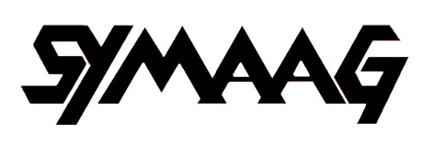

SOUTH YORKSHIRE MIGRATION AND ASYLUM ACTION GROUP

ANNUAL REPORT 2011/12

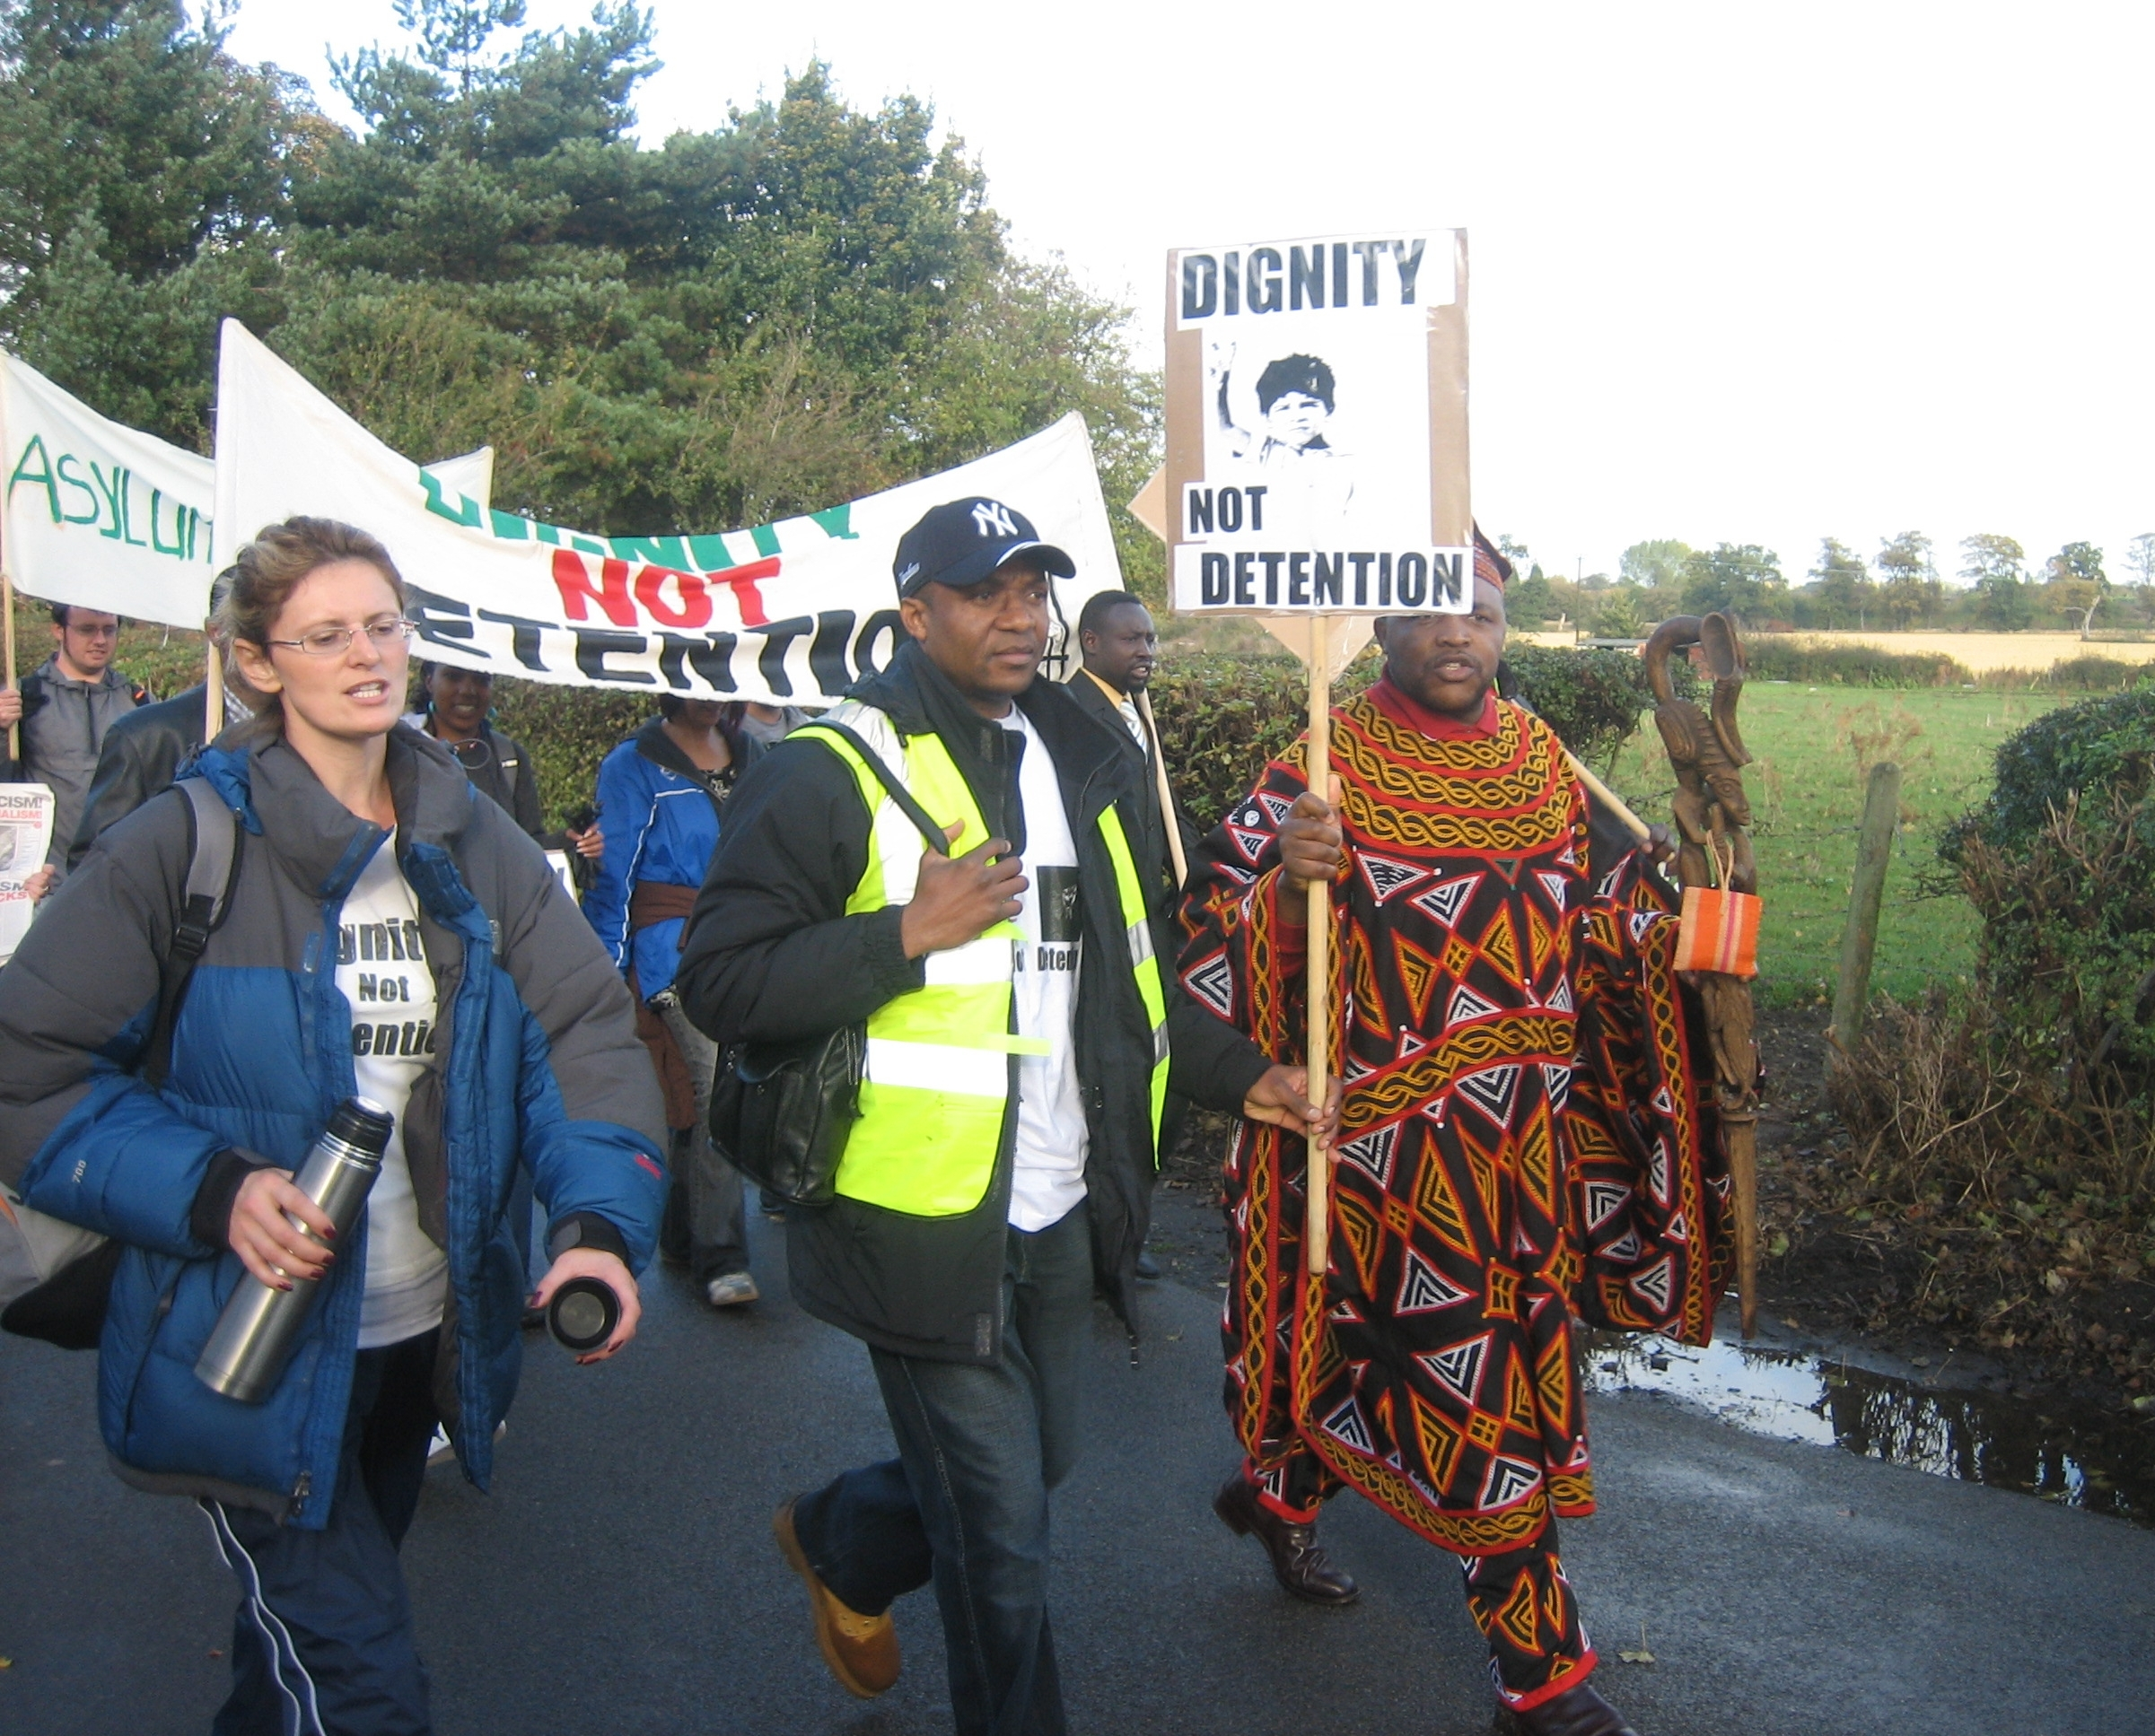

“Dignity Not Detention” 3 day March, Sheffield to Lindholme 2007

Introduction

- On 11 June 2007 a public meeting was held in Sheffield at which it was agreed to set up the South Yorkshire Migration and Asylum Action Group (SYMAAG) with the following terms of reference:
‘To campaign for action by Government and others to improve the position of asylum seekers (particularly those who have been refused) and exploited migrant workers (including the victims of trafficking).’

- From then on, SYMAAG held monthly meetings at Scotia Works, which were well attended by asylum seekers and refugees as well as other activists from all over South Yorkshire. SYMAAG soon began to organise major events, such as a March to Lindholme Detention Centre and public meetings on the plight of Darfuri asylum seekers and asylum and health. On 21 April 2008, SYMAAG held its inaugural Annual General Meeting at which a Constitution was agreed and the Group became formally constituted, with an elected Executive. Since then, SYMAAG has continued to be a very active campaigning organisation

- This is SYMAAG’s fourth Annual Report and relates to the year ending April 2012. This is the second year during which the Coalition Government has been in office. They have continued largely to follow the asylum policies of the previous Government, except that their wider cuts agenda has meant serious cuts in the resources allocated to asylum work, particularly in the voluntary sector. Moreover, Coalition immigration policies are much more restrictive that those of the Labour Government.

SYMAAG meetings and information

4. We have continued to hold open meetings roughly every month or two at
Scotia Works as well as monthly Executive Committee meetings. Our open
meetings have seen discussions on the “Arab Spring” events (see point 22),
migrant domestic workers (see point 13) privatisation of asylum housing
(see point 16) and Uganda (see point 23) with expert guest speakers. We
have also organised public meetings – on South Sudan and migrants in
Libya - jointly with other organisations and provided speakers for other
campaigning groups.

Meetings and information flow summary 2008-2012

 | 2011-12 | 2010-11 | 2009-10 | 2008-09
“SYMAAG News” bulletins | 12 | 13 | 22 | 31
SYMAAG email contact list | 546 | 483 | 460 | 300
Individual emails received | 1390 | Approx 1000 | Approx 700 | Approx 500
Average attendance at regular SYMAAG meetings | 13 | 14 | 16 | 20
SYMAAG website hits | 850 | n/a | n/a | n/a

5. A major innovation has been the introduction of the SYMAAG website - http://www.symaag.org.uk/ and the use of social media This enables information from our organisation to receive much wider coverage. While our website is still at an early stage in its development, it is already being extensively used, with 850 hits from 633 individual users since February 2012. We place on record our gratitude to Sam Musarika for his help with this project. SYMAAG now also has a Facebook page (with subsidiary Facebook event pages) and can be followed on Twitter (see @SYMAAG). Facebook has also been very useful in mobilising for our campaign against G4S housing asylum seekers.

Influencing politics and the media

6. SYMAAG seeks to influence the public, the media and politicians in favour of more humane and compassionate policies towards asylum seekers and other migrants. Unfortunately, the distorted picture of asylum in much of the media helps to generate prejudice, which in our view has excessive influence on politicians.

7. On 26 August 2011 we, along with other local asylum organisations, had our second meeting with Nick Clegg MP, Deputy Prime Minister. We raised:
- the need for independent initial decision making (as in Canada) on asylum cases,
- the new arrangements for child detention, where Mr Clegg took credit for its almost complete elimination, but we were worried that some detentions till occurred;
- the handling of outstanding legacy cases,
- the danger of forcible returns to Zimbabwe,
- the need to monitor what happens to returned asylum seekers; we subsequently sent Mr Clegg the Justice First Report ‘Unsafe Return’ which details the ill-treatment of asylum seekers sent to the Democratic Republic of the Congo by the Home Office; and
- the need to preserve the Overseas Domestic Workers Visa.

Mr Clegg undertook to follow up points that we raised and the meeting led to some extensive correspondence with Home Office Ministers on these topics.

8. We have continued to be disturbed at the impact of the Coalition Government’s cuts programme on voluntary sector bodies which support asylum seekers, such as the Refugee Council and the Northern Refugee Centre – with whom we work closely.

9. Our biggest campaign has been over the Government decision to transfer housing for asylum seekers in Yorkshire to G4S (see paras 16-20 below).

10. Current asylum policies cast doubt on the Government’s commitment to human rights. Accordingly, in November 2011, one of our Executive members, John Grayson, made a submission on behalf of SYMAAG and other local asylum organisations to the Universal Periodic Review by the UN of the UK Government’s Human Rights Record. This submission concluded:

‘the phrase ‘inhuman and degrading treatment’ in Human Rights declarations describes exactly the treatment of asylum seekers and many migrants by the UK Government and the UK Border Agency. This has become clear in Sheffield and South Yorkshire over the last ten years through hundreds of cases we have experienced where asylum seekers have been left destitute, homeless, refused access to health care, subject to degrading and inadequate forms of support and payments and refused the right to work to support themselves. In our view, the Government is in clear breach of its own Human Rights Act guaranteeing the ‘Right not to be….. treated in an inhuman or degrading way.’

11. In April 2011, City of Sanctuary, on behalf of various local asylum organisations including ourselves, made a submission to the Fairness Commission set up by Sheffield City Council. The submission argued that ‘Asylum seekers are arguably the most unfairly treated people in Britain.’ While much of this was caused by decisions taken at national level, ‘we believe it can be mitigated by attitudes and action taken locally’. The submission referred to the extensive network of support provided by voluntary bodies in the city. It recalled the City Council’s unanimous decision in 2007 to declare Sheffield a ‘city of sanctuary’ and pointed to the many challenges to making that a city-wide reality. It called for the City Council to maintain an overview of what is happening to asylum seekers and refugees and when necessary to take action to ensure that those seeking sanctuary are given the welcome they should expect.

12. Turning to immigration more generally, the Government is pursuing an extremely restrictive policy in order to fulfil the Conservative Party pledge to
reduce net migration to ‘tens of thousands per annum’ by 2015. This is a misguided goal because of its impact on individuals and families, because it will damage Britain’s economy and standing in the world (eg through restrictions on overseas students) and because it appears to be unachievable in any case. In the year to June 2011, net migration remained at the record level of 250,000, owing to an unusually low level of emigration from the UK.

13. Owing to the many issues arising on the asylum front, we have not been able to pursue these wider migration issues as much as we would wish. However, we did join the campaign against one part of the Government’s restrictive agenda –its plan to abolish the overseas workers domestic visa. This visa enabled domestic workers, brought into this country by wealthy foreign nationals, to complain about abuse and where necessary to change employers. Unfortunately, the Government has now decided to restrict such domestic servants’ stay in the UK to a maximum of 6 months and to ban them from changing employers. Once more, anti-migration obsessions have triumphed over common sense and human rights.

Improving conditions of asylum seekers: Discussions with UKBA

14. From the experience of our asylum seeker and refugee members and supporters, we are able to raise issues of real practical importance to asylum seekers. We also hear from our members about the process through which those whose asylum claims are rejected are thrust into destitution and/or dependence on voluntary sector help, even though their countries are too dangerous for them to be sent back.

15. On 31 January 2012, we, together with other local asylum organisations, met the UKBA Local Immigration Team. We raised the following issues:
- Housing, including the contract with G4S (see paras 16-20);
- Claims for asylum, including outstanding legacy cases, where there had been an unfair change in the criteria being applied;
- Cases where granting discretionary leave of only 2 or 3 years prevents people from bringing in dependants;
- Treatment of the claims of young people as they reach the age of 18;
- Enforcement, including policy on detention and deportation;
- Azure cards;
- Travel costs when making a claim or signing on;
- Voluntary work for asylum seekers.
Our representatives included asylum seekers and refugees who could describe from personal experience some of the indignities and deprivations they had suffered. UKBA agreed to follow up certain individual cases and also to write to us on various topics. It was a worthwhile meeting, even if we were astonished by the grotesque Orwellian over-regulation that exists on certain topics eg we were told that in general asylum seekers need to seek permission before doing voluntary work, but that all voluntary work by refused asylum seekers is banned. We will seek a further meeting in the near future.

Asylum housing: the case of G4S

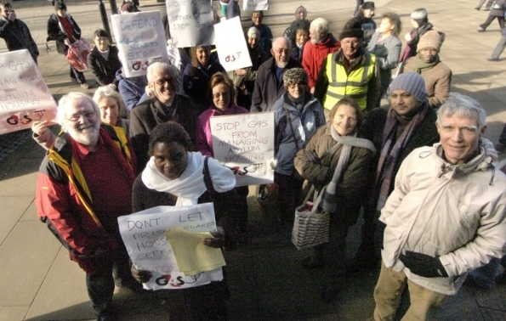
Demonstration against G4S housing asylum seekers outside Sheffield Town Hall February 15th 2012. Picture from Sheffield Star

16. In recent years, asylum housing in South Yorkshire has been managed by a consortium of local authorities under contract to UKBA. Though far from perfect, the system has worked fairly well. In Sheffield it has had the additional benefit of involving the local authority directly in the asylum system and enabling it, along with the voluntary sector, to help ensure that asylum seekers are welcomed and cared for in Sheffield despite the harshness of the national regime.

17. Against this background, there was great concern at the news that Compass, UKBA’s procurement organisation, was awarding the contract for asylum housing in Yorkshire from 2012 onwards to G4S, the mammoth international security organisation, which lacks previous housing experience (and incidentally uses Bahrain as a tax haven). G4S’s reputation among asylum seekers is affected by its responsibility for detention centres and deportation and its poor record in discharging these responsibilities. G4S lost the contract to supply escorts in forcible deportations after the death of an Angolan deportee – two G4S staff faced criminal charges. As regards its role in detention, in 2010, 773 complaints were lodged against G4S by detainees, including 48 claims of assault. It was no wonder that a Zimbabwean asylum seeker in Sheffield said he was fearful of ‘prison guards’ managing his housing. Surely asylum seekers would think twice before reporting problems with their accommodation to a body with G4S’s reputation.

18. We were also anxious about the disruption likely to be caused. All asylum seekers in local authority accommodation in Sheffield will have to be moved out during 2012. This, combined with the squeeze on prices payable under the contract, could cause G4S to use some of the poorest sub-contractors and to move many asylum seekers into the cheapest accommodation in South Yorkshire, regardless of disruption of schooling for children, medical services and support from voluntary networks. We also noted that Yorkshire’s situation was not unique: all over the country these housing contracts were being switched to huge security or outsourcing organisations.

- We decided to launch a big campaign which included the following:
  - A letter of protest published in the Yorkshire Post from 28 academics with expertise in housing, social studies, human rights etc. In addition, one of our Executive members, John Grayson, has written a series of articles about the issues;
  - Two demonstrations outside Sheffield Town Hall, followed by marches to UKBA’s Vulcan House; these have received local and national press, radio and TV coverage;
  - A petition to Sheffield City Council; Councillors applauded our presentation; we understand that subsequently the Council has registered its concerns about the development;
  - Letters to MPs: one of these led to an investigation of the procurement process by the National Audit Office to which we contributed evidence;
  - Representations to Safeguarding Children Boards in Kirklees, Sheffield and Barnsley seeking their intervention to ensure that UKBA is discharging its responsibilities to children.

- Our campaign has not prevented Compass from awarding the contract to G4S after ‘due diligence’. We met Compass and G4S on 24 February and G4S sought to reassure us that their housing work would be entirely separate from their security work, that they were acquiring housing expertise, that they would seek to minimise disturbance for asylum seekers and would demand high standards from their sub-contractors. We shall keep the management of this contract by UKBA and G4S under searching scrutiny, encouraging the formation of asylum seeker tenants’ federations linked to established tenants’ federations.

Campaigns for individual asylum seekers

21. The Committee to Defend Asylum Seekers, locally and the National Coalition of Anti-Deportation Campaigns, nationally have taken the lead in campaigns for individual seekers. We have supported many campaigns for individual asylum seekers, including public demonstrations, petitions, lobbying and attending court hearings. We have made a point of doing our utmost to defend any SYMAAG members, particularly Marian Machekanyanga from Zimbabwe. Marian’s campaign continues (and you will find a petition in support of Marian along with this report). The most notable campaigning success was with Bavwidi Mpanzu (Djoly) from the Democratic Republic of Congo who won his right to remain in September after a long campaign led by the Africa Time community group and SYMAAG.

Work on countries and with refugee community organisations

- One of SYMAAG’s greatest strengths is its refugee and asylum seeker membership, their in-depth knowledge about troubled areas of the world and the contacts which they facilitate with refugee community organisations.

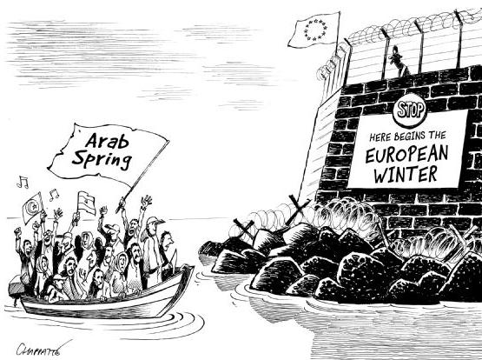

- The most striking development of the last year has been the Arab Spring and the inconsistencies in apparent Western support for the uprisings and the reluctance of EU countries to accept people seeking asylum from those countries. These discussions ranged more widely than asylum and migration issues but are valuable among other things in helping to explain why people seek asylum.
- Syria. In August, two speakers from Syria informed us about the Syrian uprising describing Syria as “the democracy of live ammunition”. SYMAAG protested to the Syrian Embassy in the UK
- Yemen. In October Abdul Razak from the Sheffield Yemeni Community Association spoke to us about the protests against the Saleh Government and the history of Yemeni migration to Sheffield.
- Eritrea. Bereket Kahsai from the Eritrean Community Organisation informed us of the difficulties facing an Eritrean “Arab Spring” and of patterns of Eritrean migration
- Libya. SYMAAG worked with the University of Sheffield’s African Affairs Network to organise a film showing and discussion of conditions for migrants in Libya and the repressive role of FRONTEX, the EU border agency. Along with speakers from the Eritrean community and SYMAAG, a representative of the new Libyan Embassy attended the film showing and meeting and heard our concerns that life for migrants in Libya remained oppressive despite the overthrow of Gaddafi. He assured us that the new Libyan Government would sign the 1951 Refugee Convention.

- Among the other country issues which have received attention in the last year are:

- Zimbabwe: We are disturbed that the Home Office has resumed forcible deportations to Zimbabwe including prominent Zimbabwe Vigil member David Moyo. Our Zimbabwean members follow the news from their home country carefully and remain deeply apprehensive about the situation there. We have taken these issues up with Nick Clegg on two occasions. We have noted the Home Office’s use of remarks made by Movement for Democratic Change leader Morgan Tsvangirai’s that Zimbabweans should returns to the country.

- Uganda: With the benefit of regular reports from SYMAAG’s Rodrigo Edema we have monitored the repression of opposition forces and made representations to the BBC, Archbishop of York John Semtanu (originally a migrant from Uganda) and MPs. We were pleased to invite Dr Baiga Lulume, a shadow cabinet member and Ugandan opposition MP. We have noted the increasing US military presence in Uganda and surrounding countries.

- Sudan: In SYMAAG’s early days, we and others protested when UKBA compelled Sudanese asylum seekers to be interviewed by a Sudanese Government agent. We said that this was illegal and contrary to UKBA’s own rules. Such interviews could lead to the victimisation by the Sudanese Government of relatives of those interviewed. We therefore find it very disturbing that recently a similar incident occurred again in April 2012 with UKBA calling in Sudanese asylum seekers to be interviewed by Embassy officials. We have collected testimonies from those interviewed and worked with the Sudanese community, local legal experts and national organisations to build an ongoing case against the UKBA’s continuing malpractice and worked with Northern Refugee Centre and Waging Peace to compile a report “The Borders Agency Are Playing a Game to Scare Us” which has been sent to UKBA and various MPs.

- South Sudan: We organised a public meeting in English and Arabic with a Sudanese speaker and eyewitness to the attacks on newly independent South Sudan by Sudan. We have continued to support efforts to publicise this little-reported conflict and its consequent forced migration.

- Eritrea: We have worked with the Eritrean Community Organisation (ECO) to oppose visits by the Eritrean Ambassador to Sheffield and the related victimisation of opposition community members here. We have worked with the ECO to campaign against the practice of involuntary taxation of Eritreans outside the country to fund the Eritrean Government. We are aware that there are a number of Eritrean community organisations in Sheffield and have sought to maintain a dialogue with them all, also facilitating mediation between them.

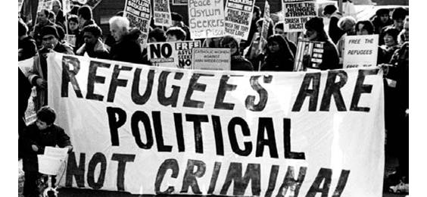

Work with other campaigning organisations

- We can achieve greater impact if we work with other organisations, such as ASSIST, City of Sanctuary and Committee to Defend Asylum Seekers and Student Action for Refugees We have good working relationships with all of these groups. Our approaches to Nick Clegg have been strengthened by the fact that we were a coalition of organisations. Other organisations with which we have worked are South Yorkshire Refugee Law and Justice, Northern Refugee Centre (NRC), Refugee Council, Amnesty International, Sheffield Trade Union Council, Barnsley Trade Union Council, Sheffield Unison trade union, African Affairs Network, the Development and Empowerment for Women’s Advancement group, Waging Peace, the National Coalition of Anti-Deportation Campaigns, University of Sheffield African Affairs Network, Migrant Rights Network, the Institute of Race Relations, the Children’s Society and the Africa Time community organisation.

Northern Refugee Centre

25. We have continued to work closely with NRC, making a joint submission to the Universal Periodic Review by the UN of the UK Government’s Human Rights Record and working jointly on the report “The Borders Agency Are Playing a Game to Scare Us” (about the April 2012 UKBA/Sudanese Embassy interviews of Sudanese asylum seekers) . We would particularly like to acknowledge the practical support we receive from NRC.

South Yorkshire Refugee Law and Justice group

26 We are glad that South Yorkshire Refugee Law and Justice is now operational. It was created following a meeting which SYMAAG and STAR organised in March 2010. Drawing heavily on the expertise of volunteers to whom it offers training, it aims to help refugees collate evidence to support fresh claims and appeals by researching conditions in their country of origin. It is seeking accreditation by the Office of the Immigration Services Commissioner which will enable it to offer legal assistance and advice and is now a registered charity.

Women asylum seekers

27. A year ago, we resolved to seek greater involvement of women asylum seekers in our work. Though prominent women asylum seekers and female activists are involved with SYMAAG we have not achieved our goal. We have however campaigned on the issue of migrant domestic workers and supported the Refugee Women’s Conference where SYMAAG held a workshop. We continue to have a good relationship with Development and Empowerment for Women’s Advancement group, an initiative formed by local asylum-seeking and refugee women.

Management and finance

30. We are hugely indebted to our indefatigable and expert volunteer Secretary, Stuart Crosthwaite, who is now at the centre of a remarkably large email and website information network. SYMAAG’s high level of activity would not be possible without him.

31 Our financial position continues to be healthy. We have been able to pay travel costs where necessary for those attending meetings, to buy a loud hailer and to finance our new website. We are very grateful to our Treasurer Robert Siamtinta for his contribution.

Conclusion

32. Our experience over the last year or so has been mixed. We are pleased that some asylum seekers who SYMAAG has supported have been given leave to remain. But the harshness of the overall regime remains and the Government’s drive for economy has made some things worse, notably the arrangements for asylum housing. Moreover, regardless of Liberal Democrat policy, Government is pursuing a remarkably negative Conservative immigration policy.

33. SYMAAG has remained an extremely active campaigning organisation, in which asylum seekers and refugees themselves are closely involved. We have had access to powerful people – the Deputy Prime Minister, other MPs, UKBA officials, G4S senior management and others. We have also managed on many occasions to catch the attention of the local, regional and national media. While we cannot claim that we have caused reversals of policy, we have shown that the anti-immigration tabloid press is not the only constituency that needs to be taken into account.

SYMAAG
May 2012

Post: c/o Scotia Works, Leadmill Road, Sheffield S1 4SE

Email: dignitynotdetention@yahoo.co.uk

Phone: via 0114 241 2780

Website: www.symaag.org.uk/

Facebook: http://www.facebook.com/SYMAAG

Twitter: @SYMAAG

