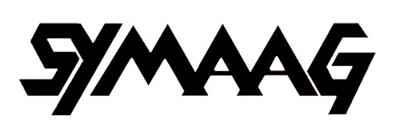 | 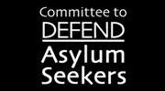  Sheffield

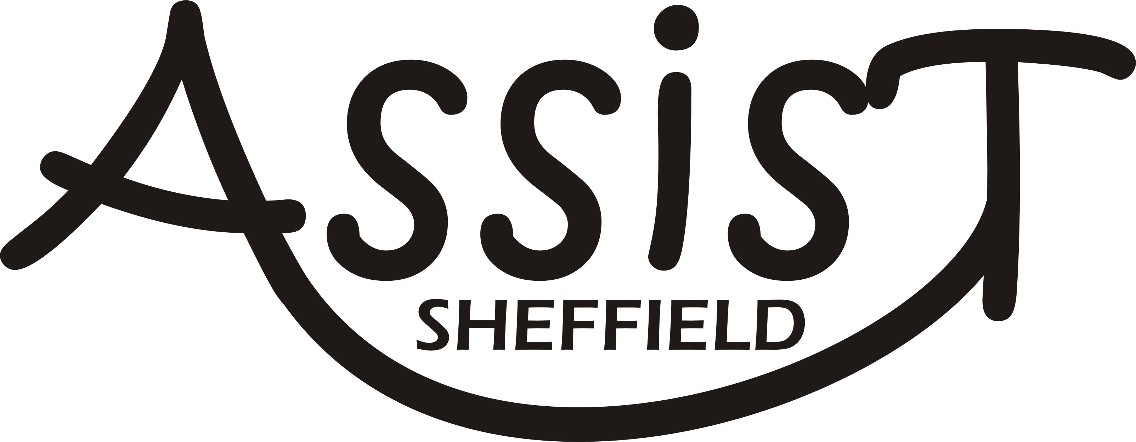


c/o 45 Oakhill Road
Sheffield S7 1SJ
1 June 2012
Rt Hon Nick Clegg MP
85 Nether Green Road
Sheffield, S11 7EH

Dear Mr Clegg,

ENFORCED REMOVALS TO ZIMBABWE

You kindly sent me Theresa May’s letter of 16 April in which she defended the UKBA’s policy of carrying out enforced removals to Zimbabwe on a case by case basis. We are concerned that this policy is putting people’s safety at risk. UKBA recently succeeded in its third attempt to return David Moyo forcibly to Zimbabwe. On 28 May we held a special meeting with MDC representatives and other Zimbabweans living in South Yorkshire and we have consulted legal experts about the Home Secretary’s letter. I am now writing on behalf of all the organisations listed above to urge you to take up the following points with the Home Secretary:

First, she relies heavily on the judgement in the case of EM and Others (Returnees) Zimbabwe CG[2011] UKUT 98 (IAC)]. But the Court of Appeal has now granted an application for permission to appeal against this judgement, thus strengthening the case for a complete suspension of enforced removals.

Secondly, she ignored the fact that the European Union is still imposing sanctions on Zimbabwe because of the suppression of human rights.

Thirdly, Theresa May relies on Morgan Tsvangirai’s call in 2010 to refugees to return home and help rebuild their country. However, she ignored conflicting views among MDC Ministers in Zimbabwe. For example, on 4 April 2011 co-Home Affairs Minister, Theresa Makone, made an extraordinary statement in Leeds:
“I have personally advised my daughter who is resident in Britain not to come home now because the situation is critical. Despite being a minister myself, I have gone into hiding, running away from the very police who report to me. If I am forced to hide away, then what about my daughter?
“The irony is that I am the boss of Zimbabwe police, they report to me, strangely they also come to me with orders to arrest me. It is true that I have been in hiding in Zimbabwe for some time despite being a cabinet minister. The question is that if these people can persecute me, as a cabinet minister what about you ordinary people?.....
“On that note, I am engaged in secret talks with British authorities over the recent ruling by the British Home office that the UK should remove failed Zimbabwean asylum seekers. This is because I know Zimbabweans are unsafe back home.”
How can Zimbabwe be ‘safe’ if Theresa May’s opposite number there has to hide from the police?
Finally, a constitutional referendum and an election are likely in 2012-13, making this an exceptionally dangerous time in Zimbabwe. The F and CO website notes that:
‘During the election campaign of 2008 and its aftermath, there were numerous politically motivated attacks across Zimbabwe, including abductions, and the assault, torture and murder of opposition supporters, NGO workers, lawyers and those perceived to be against President Mugabe and his ZANU(PF) party.’
The Zimbabwean community in South Yorkshire follows developments in their country very closely. They are deeply apprehensive about their prospects if they return home.
I would be grateful if you could take this up again with the Home Secretary and ask
(a) what happened to the talks that were taking place in 2011 with Theresa Makone, and
(b) why, given the considerable legal and political uncertainties, cannot UKBA hold back on forced returns until the situation can be properly reviewed after the next election.
Yours sincerely,

David Price
Chair, South Yorkshire Migration and Asylum Action Group, on behalf of ASSIST, City of Sanctuary, Sheffield and CDAS Sheffield.

