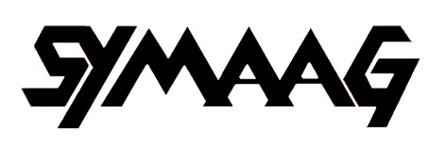

South Yorkshire Migration and Asylum Action Group
c/o 45 Oak Hill Road
Sheffield S7 1SJ
0114 296 0806
davidprice2@googlemail.com
10 March 2012
Rt Hon Nick Clegg MP
85 Nether Green Road
Sheffield, S11 7EH

Dear Mr Clegg,

Deportations to Zimbabwe
You will recall that, at our meetings on asylum, we have expressed our concerns about Home Office threats to deport refused asylum seekers to Zimbabwe. We were therefore very disturbed recently to learn of the Home Office’s detention of David Moyo with the intention of deporting him to Zimbabwe via Kenya on 1 March. He was taken to Heathrow where, according to his mother, he asked to speak to the pilot who refused to take him. He is apparently now back in detention. He is a human rights activist with the Zimbabwe Vigil which has been demonstrating outside the Zimbabwe Embassy in London every Saturday. The Vigil movement believe he would have been at considerable risk if he returned. David Moyo is not unique. We have heard that at least 10 Zimbabweans have been deported from the UK since the resumption of deportations in April last year.

While some Zimbabwean asylum seekers in Sheffield have been given refugee status, there remain a significant number who have not. They are alarmed by reports of threatened deportations like that of David Moyo, as Zimbabwe is a dangerous place for political activists with a record of opposition to Mugabe. This seems also to be the view of the F and CO. Their country profile reads:
‘human rights issues are still of serious concern. ….. human rights defenders continue to be harassed, assaulted and sometimes prevented from holding peaceful demonstrations. Repressive legislation remains in place, limiting fundamental freedoms. Prison conditions are cause for serious concern, torture occurs and there is a general culture of impunity, whereby perpetrators of abuses are not prosecuted.’
Moreover, we understand that Zimbabwe’s Co-Home Affairs Minister Theresa Makone has met with Damian Green about the possibility of granting a deportation amnesty for failed Zimbabwean asylum seekers until the next election.

We would urge you to impress on your Home Office colleagues the need on human rights grounds for an ongoing ban on forcible returns to Zimbabwe.

Yours sincerely,

David Price

