Demonstrate against the Immigration Bill

Wednesday 18th December 12 noon in Sheffield

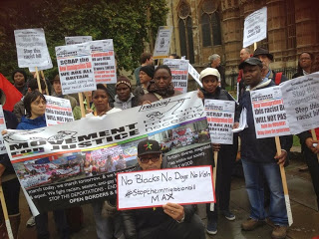
Protesting outside Parliament against the Immigration Bill

The Immigration Bill being forced through Parliament has been described by one MP as “the most racist piece of legislation I have seen”. Home Secretary Theresa May said the aim of the Bill was to “create a really hostile environment” for what she called “illegal migrants”.
Is this the kind of society we want to live in?

The Bill is not yet law: that’s why we should protest against it now. We’ve chosen December 18th because it’s International Migrants Day.

What does the Bill propose?

- That private landlords and banks should check the immigration status of prospective tenants and customers. But understanding immigration status is complex. This will lead to racial profiling and discrimination.
- To limit appeal rights and an increase in appeals that can only be made from abroad. But Home Office decision making is poor - 40% of appeals succeed. Taking away the right to appeal will make the system even more unfair.
- A charge on all migrants, without indefinite leave to remain, for use of the NHS. This idea is based on the myth of health tourism. But migrants are more likely to being working in the NHS than using it: 30-40% of all doctors and nurses were born outside the UK.

We think that the only people who should find the UK “a hostile environment “ are those who seek to promote racism and division in the pursuit of anti-immigrant votes

Meet at the bottom of The Moor (near new market) at 12noon. March to the Town Hall by 12.30 then to UK Border Agency Vulcan House at 1pm

Get your community group, trade union or tenants group to support our protest

Organised by the South Yorkshire Migration and Asylum Action Group (SYMAAG)
Email: dignitynotdetention@yahoo.co.uk Website: www.symaag.org.uk
Follow us on Twitter @SYMAAG and find us on Facebook

