CALLING ALL MIGRANT RIGHTS ACTIVISTS, MEDICAL PROFESSIONALS, NHS WORKERS AND TRADE UNIONISTS

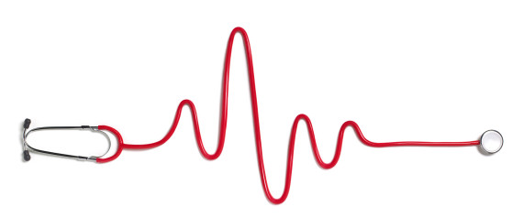

The Department of Health has recently announced proposals to charge overseas visitors and migrants for their use of primary and emergency healthcare.
Under these new proposals, those who are currently chargeable for secondary healthcare will become chargeable for all the care they receive from the NHS, apart from GP and nurse consultations. This will include introducing charges in primary care (apart from GP and nurse consultations), community care and emergency care (including ambulance services, A&E and walk-in centres).

Charging procedures in the NHS are already deterring vulnerable people seeking protection from accessing medical help, with significant consequences for their own health and wellbeing as well as public health.

Whilst we welcome the fact that people seeking asylum and refugees will continue to be exempt from new charging procedures, we are worried that vulnerable refused asylum seekers will be further excluded from accessing the healthcare that they need.

The Department of Health has issued a new public consultation on the extension of charges for overseas visitors and migrants using the NHS in England. The consultation document is accessible here.

Want to find out more?

Join SYMAAG and Regional Asylum Activism on Monday 8th February to hear about the Department of Health’s proposals and how you can feed in to the consultation.

Monday 8th February

6.30 – 8.30pm
(arrive from 6pm for tea and coffee)
Quaker Meeting House, 10 St James’ Street,
Sheffield, S1 2EW

Contact SYMAAG on symaagcentral@gmail.com or Regional Asylum Activism on yandh@regionalasylumactivism.org to register your interest for the event.

