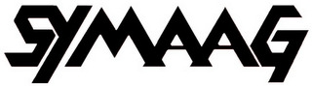 South Yorkshire Migration and Asylum Action Group
TEN YEARS OF CAMPAIGNING ON MIGRANT AND ASYLUM RIGHTS
ANNUAL REPORT 2016 / 2017
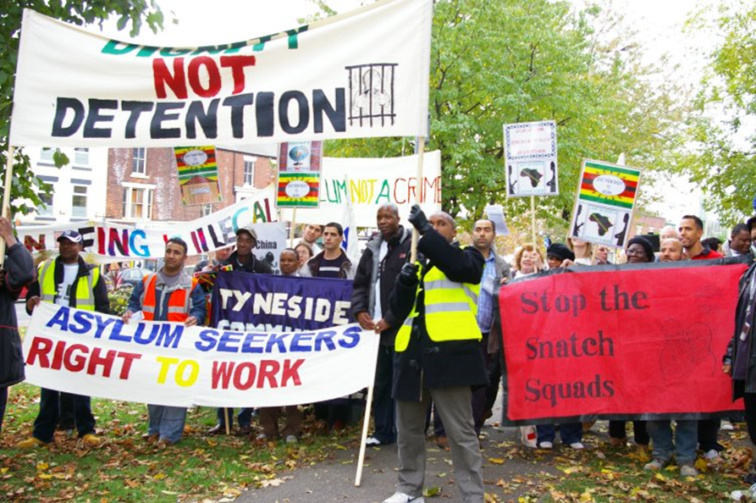
The March to Lindholme Detention Centre 2007

The Year of BREXIT
SYMAAG is nearly ten years old. Its first informal meeting was held on 5 June 2007 and its first AGM was held on 21 April 2008.We will produce a separate report charting the organisation’s history over this period. This report describes its activities in the year ending in March 2017.

The past year was dominated by the fateful Referendum on 23 June 2016 in which 52% of those voting favoured Britain leaving the EU. In South Yorkshire, the pro-Brexit vote was very high – 68% in Barnsley, 69% in Doncaster, 68% in Rotherham and a (much closer) 51% in Sheffield. South Yorkshire is a relatively poor area, so the vote may in part have been an anti-establishment protest at the treatment of the less affluent since the financial crisis of 2008. But immigration also loomed large in the Referendum debate and it seems likely that many of those favouring Brexit in South Yorkshire as elsewhere were at least in part motivated by concerns over immigration. Certainly, both the Government and the Labour Party have interpreted the vote as a call to end the UK’s exposure to free movement of labour in Europe. The Referendum outcome suggests that we in SYMAAG and similar organisations have an uphill struggle in arguing for a more tolerant and open approach to immigration and a more compassionate approach to asylum. This makes our campaigning more challenging but all the more important.
Don’t let them drown
In Refugee Week in June 2016 SYMAAG sponsored the showing of a film on deaths in the Mediterranean and a talk by Dr Simon Parker from York University. In 2016 5000 people died in the Mediterranean and Aegean attempting to enter the E.U. Over the past year SYMAAG has continued to highlight what a “deterrent” asylum system actually means in death and suffering – across Europe and in the U.K.
Stuart, our secretary went to the Calais camps, taking supplies and Sheffield people still continue to make solidarity visits regularly. Some of the Sheffield activists who were involved in the actions and contacts in Calais have, with the assistance of the national organisation Right to Remain, developed the Early Asylum Support group contacting people who have managed to get across the Channel and assisting them with preparing for their asylum interview.

SYMAAG strategies for the year…and how we did
In July 2016, we held a strategy meeting which was well attended by representatives not just of SYMAAG but also of our sister organisations.
A number of priorities for the year were agreed and the progress achieved on them over the year were as follows:
1. After nearly ten years of existence members decided to hold our first social event, a successful party on 19 November! Manuchehr, Zhila, and Violet organised and the Syrian National Orchestra, an Iranian folk singer and David and Robert starred on the night.
2. Combating hate crime and improving reporting. This reflected a wave of hate crimes following the EU Referendum and even before that hate crimes in Sheffield were increasing. (On 27 October 2016, the Star reported an increase of 22% in hate crimes in Sheffield comparing 2015-16 with 2014-15). In the event, City of Sanctuary took the lead on this issue and introduced its own reporting system.

3.BREXIT. There was concern about the rights of EU workers in the UK and a proposal that SYMAAG meeting should hold a meeting on this subject. We have not held such a meeting, as the issue has featured so strongly in subsequent national political debates, with the Government seeing it as part of the bargaining with EU partners, while Labour has recently proposed a unilateral undertaking to preserve EU migrants’ rights.

4. Building SYMAAG as an effective campaigning organisation. As a volunteer organisation, SYMAAG does not have heavy overheads, but it does need more money for its campaigning. Finance is discussed elsewhere in this Report. We also need to become more representative of the whole of South Yorkshire. At present, our main membership is in Sheffield, while we also have strong support in Barnsley, but we are under-represented in Rotherham and Doncaster.
Again, we have to report that we have had little organised SYMAAG activity in Rotherham and Doncaster. In Doncaster Paul our EC member there, produces one of the best asylum and migration newsletters anywhere and effectively advertises our campaigns and meetings.

5. Campaigning on G4S. SYMAAG, along with ASSIST and City of Sanctuary Sheffield has monitored the world’s largest security company and its (mis)management of asylum seekers homes in South Yorkshire. John Grayson has continued to research conditions alongside asylum tenants who have had the courage to speak out against G4S as their landlord, and write about asylum housing on www.OpenDemocracy.net and for the Institute for Race Relations news service www.irr.org.uk
SYMAAG has led on the campaigning to stop G4S forcing asylum tenants to share bedrooms in HMO’s (Houses in Multiple Occupation) throughout South Yorkshire. Sheffield City Council announced two years ago that they would enforce the ban on G4S.G4S has resisted and is still resisting even though there is a ban on new tenants having to share from April and everyone having the choice of a single room by August 2017.
SYMAAG organised two “hearings”, one in Sheffield, and one in Barnsley where G4S tenants gave evidence which we sent to the parliamentary Home Affairs Committee (HAC) Inquiry into Asylum Housing which reported in January 2017 with widescale criticisms of G4S and the other contractors Serco and Clearsprings.
The HAC Inquiry also supported a ban on bedroom sharing and widescale use of HMO’s. Despite this criticism, in December 2016 The May government extended the contracts with G4S, for another two years to June 2019.
In summer 2016, members of SYMAAG with Brass Moustache films, made a documentary about asylum housing, called The Asylum Market, which was shot mainly in Sheffield. The film dealt with the intimidation of tenants by G4S, and the BBC had agreed to screen clips of the film, when the HAC Report on Asylum Housing was published on 31 January.G4S put pressure on the BBC and the film was pulled. Other media outlets followed suit, but the producers then simply released the film widely over social media.

StopG4S Sheffield and Northern groups
SYMAAG is part of a wider movement to highlight and contest human rights abuses by G4S.In Sheffield we cooperate with Palestine Solidarity Campaign and nationally with War on Want and Palestine prisoner organisations to highlight G4S activities in providing security services in Israeli prisons where Palestinian children are detained. This year the long campaign which has included demonstrations at G4S Annual General Meetings and international boycotts finally resulted in G4S selling its major security businesses in Israel.

Northern StopG4S, with the Manchester group in the lead, managed to persuade the Labour Party to stop using G4S for security at its annual conference.

In Sheffield StopG4S with ASSIST and City of Sanctuary have engaged with the Sheffield City Council to try to ensure that an “ethical procurement” policy can be introduced to stop companies like G4S getting contracts with the Council. This process after two years is still ongoing!
A Workshop Day “Profiting from Children in Prison: G4S and outsourcing.” was held on 12 November to focus on G4S contracted children’s prisons in the U.K. (Youth Offender Institutions), and in Israel. Carolyne Willow author of Children behind Bars and Eric Allison prison correspondent of the Guardian led the workshop with their work on the BBC TV Panorama expose of Medway, the G4S – run prison for 12 to 17 year olds, in January 2016.

6.Immigration Detention. SYMAAG ‘s banner says, “Dignity not Detention”, and since our 2007 march to the then Lindholme Detention Centre, actions to end immigration detention have been at the heart of our campaigning. There are ten detention (Immigration removal) centres in the U. K. nine are privatised (G4S manages two and provides health ‘care’ at Yarl’s Wood near Bedford). There is still no time limit on detention in the U.K. (all other countries in Europe have limits) SYMAAG supported the ‘Shut Down Yarl’s Wood’ demos in September and on 3 December. After two deaths in Morton Hall Detention Centre, near Lincoln (managed by the Prison Service) in December and January SYMAAG organised a demo on 7 March a few days before a very critical report on the centre by H.M. Prison Inspectorate. Pictures from the demonstrations below from Lesley Boulton and Manuch.
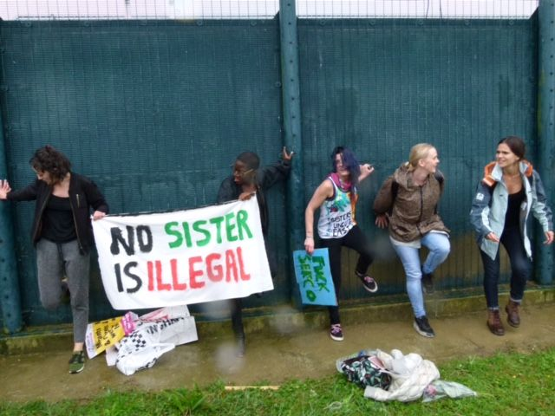
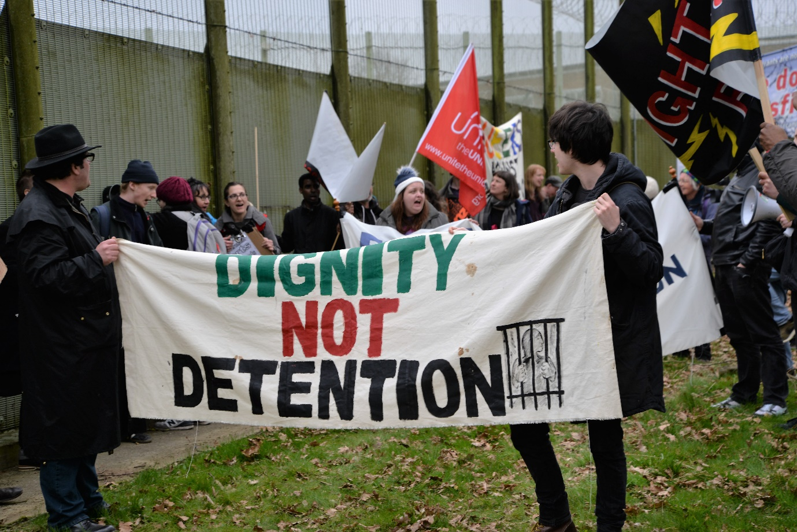

Refugees in Sheffield …from Chile to Eritrea
During the year, SYMAAG has held meetings on the refugee issues facing particular countries. The first was held on 18 January with the Chilean community entitled 'When we reached for the stars', and presented the success story of the movement of Chilean refugees to Sheffield following Pinochet’s coup in 1973. At the second meeting in March, Martin Plaut, former BBC East Africa correspondent, gave a lucid and compelling answer to the question: ‘Why are so many Eritreans forced to become refugees.?’
Lobbying our M.P.’s
During the year, we have kept in touch with South Yorkshire MPs. Louise Haigh MP spoke at our 2016 AGM and we were greatly encouraged by her strong commitment. We were in touch with MPs over the shocking proposals from the Department of Justice for 500% increase in Tribunal fees and were delighted when these were dropped by the Government in November 2016. We have kept in touch with Paul Blomfield MP over detention issues, as he was Vice-Chair of a Parliamentary Inquiry which suggested a 28-day time limit for detention. We also regularly contact Nick Clegg M.P. for assistance.
SYMAAG is not a party-political organisation and SYMAAG supporters are active in the Labour Party, Liberal Democrats, the Greens, Socialist, and autonomist groups (e.g. No Borders and No One is Illegal).

Our sister organisation DEWA
We have at last increased the involvement and power of women in SYMAAG. This is the great achievement of our vice chair Violet, working in DEWA, who has worked tirelessly in directly supporting and assisting huge numbers of women in the asylum system – and beyond.

Solidarity from the Trade Union movement… and from churches and chapels
SYMAAG has increased its funding this year through donations and new affiliations from the unions: Barnsley Trades Council, UNISON Barnsley brand, NUT Barnsley, UNITE Community Branch We are actively cooperating with the unions in particular Unite who run a drop-in centre and ESOL classes in Barnsley. Our Secretary Stuart is our link to union campaigns on Benefit Sanctions and other union actions.
We are also generously supported by churches, notably St Andrews Psalter Lane Church.

Thanks to our Secretary, Stuart, with Manuch, Thupten and Muhammad
People looking at our activities and reach often think SYMAAG is a large organisation with paid staff. Of course, we are a wholly volunteer organisation dependent for our everyday survival and public profile on the work of Stuart as secretary on the SYMAAG web site and Twitter, backed up by Manuch, Thupten and Muhammad on Facebook and everywhere else!

